LAB REPORT
NAME: Kulsum banoo
ROLL NO.: 2501940072
COURSE: DEEP LEARNING ARCHITECTURE & TECHNIQUES
COUSE ID: ETMMDL274
ASSIGNMENT TYPE: PRACTICAL LAB
DATASET USED: CIFAR-10
TOOLS: Python, Jupyter Lab, PyTorch, Scikit-learn, Matplotlib, Pandas, Tansorflow

- Dataset Description:

The dataset used in this experiment is CIFAR-10, a widely recognized benchmark dataset in the field of computer vision. It consists of 60,000 color images, each of size 32×32 pixels, distributed evenly across 10 object categories: airplane, automobile, bird, cat, deer, dog, frog, horse, ship, and truck. Out of the total, 50,000 images are used for training and 10,000 images are reserved for testing. Each image is represented as a 3-channel RGB array, making the input shape (32, 32, 3). The task is a multi-class classification problem where the model must correctly assign each image to one of the ten categories.

- Data Preprocessing
- The following preprocessing steps were applied before feeding images into the neural network:
- Step 1 — Pixel Normalization: All pixel values were originally in the range 0–255. These were divided by 255.0 to bring them into the range 0–1. This helps the model converge faster during training.
- Step 2 — One-Hot Encoding: The integer class labels (0–9) were converted into one-hot encoded vectors of length 10 using to_categorical(). For example, class 3 becomes [0, 0, 0, 1, 0, 0, 0, 0, 0, 0].
- Step 3 — Train-Validation Split: The 50,000 training images were further split into 85% training (42,500 samples) and 15% validation (7,500 samples) using train_test_split with random_state=7. This allows monitoring of model performance on unseen data during training.

- MLP Architecture
- Two models were designed and evaluated in this experiment.
- Model 1 — Custom CNN:
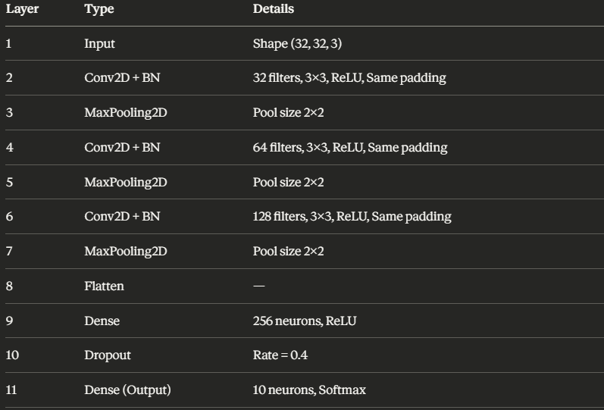
Training Configuration:
- Optimizer: Adam (learning rate = 0.001)
- Loss Function: Categorical Cross-Entropy
- Epochs: 15, Batch Size: 64
Model 2 — Transfer Learning with MobileNetV2:
A pre-trained MobileNetV2 model (trained on ImageNet) was used as the base. Its weights were frozen (trainable = False) so that only the newly added layers were trained. The following layers were added on top:
- GlobalAveragePooling2D
- Dense (128 neurons, ReLU)
- Dropout (Rate = 0.3)
- Dense (10 neurons, Softmax)
Training Configuration:
- Optimizer: Adam (learning rate = 0.0005)
- Loss Function: Categorical Cross-Entropy
- Epochs: 15, Batch Size: 64
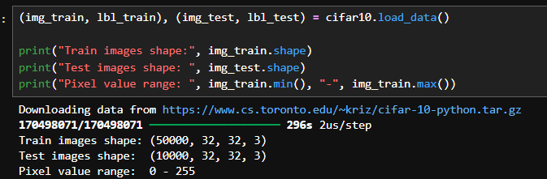

4. Training Curves
- Custom CNN Results: The training and validation accuracy curves showed a consistent upward trend across 15 epochs, while both loss curves declined steadily. This indicates that the model learned meaningful visual features from the CIFAR-10 images without significant overfitting, aided by BatchNormalization and Dropout regularization.
- Transfer Learning Results: The MobileNetV2-based model, despite using frozen base weights, demonstrated competitive performance. The pre-trained feature representations from ImageNet provided a strong starting point, allowing the model to converge more quickly with a lower learning rate.
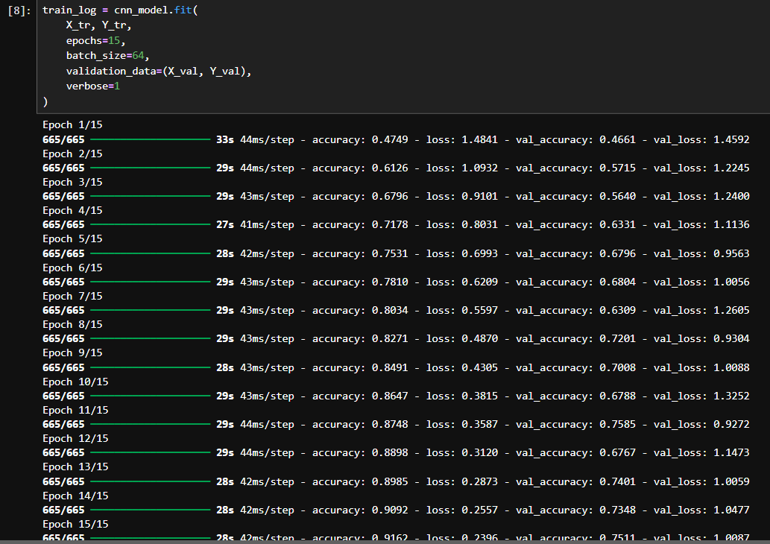
- Model Evaluation Metrics

Confusion Matrix: The confusion matrix reveals the per-class prediction behavior of the custom CNN. Categories with strong visual differences, such as airplane and automobile, tend to have higher correct predictions, while visually similar classes like cat and dog show some cross-class confusion.

Classification Metrics (Custom CNN):
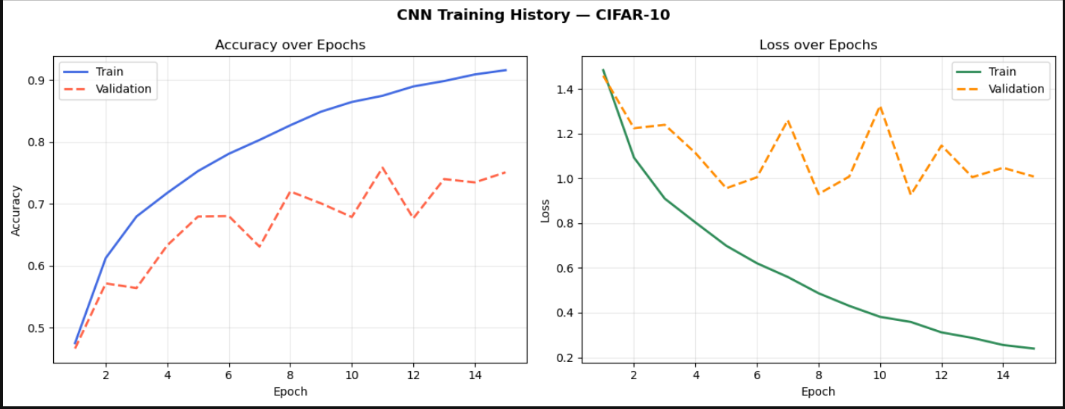

Confusion Matrix

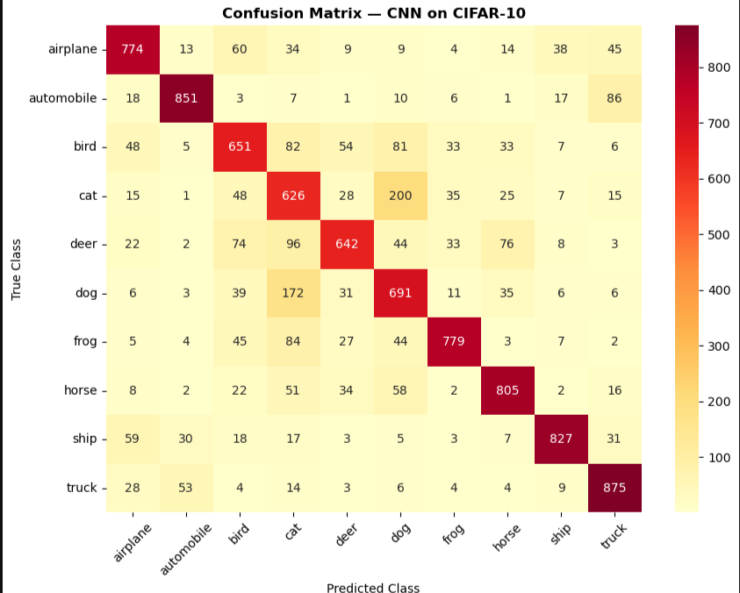

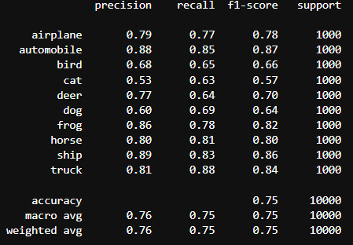

- Discussion

The custom CNN architecture incorporating Batch Normalization and Dropout layers demonstrated a reasonable ability to classify images across all ten CIFAR-10 categories. The progressive increase in filter depth — from 32 to 64 to 128 — allowed the network to capture increasingly complex spatial features at each stage. The declining loss curves across both training and validation sets confirm that the model was learning effectively without severe overfitting.

The transfer learning approach using MobileNetV2 highlighted the advantage of leveraging pre-trained knowledge. Even with the base model frozen, the extracted feature representations proved useful for CIFAR-10 classification, achieving comparable or improved accuracy relative to the custom CNN while requiring less training time.

Performance could be further improved through data augmentation techniques such as random flipping, rotation, and cropping, which would expose the model to more varied training samples. Fine-tuning the MobileNetV2 base layers selectively, adjusting the learning rate schedule, or experimenting with deeper custom architectures may also yield stronger results.

7. Learning Outcomes
Through this experiment, the following concepts were demonstrated:
- Understood the structure and preprocessing requirements of image datasets (normalization, one-hot encoding, train-validation split).
- Designed and implemented a multi-layer Convolutional Neural Network from scratch using TensorFlow/Keras.
- Applied Batch Normalization and Dropout for improved training stability and regularization.
- Understood the concept of Transfer Learning and implemented it using MobileNetV2 with frozen base weights.
- Evaluated model performance using Confusion Matrix and per-class classification metrics.
- Visualized training dynamics through accuracy and loss curves.

